Movies Final Report

# 1. Overview

This Project is divided into two parts:

1. The​ ​Story​ ​of​ ​Film:​ ​​This​ ​section​ ​aims​ ​at​ ​narrating​ ​the​ ​history,​ ​trivia​ ​and​ ​facts​ ​behind​ ​the world​ ​of​ ​cinema​ ​through​ ​the​ ​lens​ ​of​ ​data.​ ​Extensive​ ​Exploratory​ ​Data​ ​Analysis​ ​is performed​ ​on​ ​Movie​ ​Metadata​ ​about​ ​Movie​ ​Revenues,​ ​Casts,​ ​Crews,​ ​Budgets,​ ​etc. through​ ​the​ ​years.​ ​Two​ ​predictive​ ​models​ ​are​ ​built​ ​to​ ​predict​ ​movie​ ​revenues​ ​and​ ​movie success.​ ​Through​ ​these​ ​models,​ ​we​ ​also​ ​aim​ ​at​ ​discovering​ ​what​ ​features​ ​have​ ​the​ ​most significant​ ​impact​ ​in​ ​determining​ ​revenue​ ​and​ ​success.  
2. Movie​ ​Recommender​ ​Systems:​ ​​This​ ​part​ ​is​ ​focused​ ​around​ ​building​ ​various​ ​kinds​ ​of recommendation​ ​engines;​ namely​ ​the​ ​Simple​ ​Generic​ ​Recommender,​ ​the​ ​Content​ ​Based Filter​ ​and​ ​the​ ​User​ ​Based​ ​Collaborative​ ​Filter.​ ​The​ performance​ ​of​ ​the​ ​systems​ ​are evaluated​ ​in​ ​both​ ​a​ ​qualitative​ ​and​ ​quantitative​ ​manner.

# 2. Data Wrangling

## 2.1 Data Collection

The​ ​MovieLens​ ​Full​ ​Dataset​ ​was​ ​readily​ ​available​ ​at​ ​the​ ​GroupLens​ ​Website (​https://grouplens.org/datasets/movielens/​).​ ​This​ ​dataset​ ​contained​ ​26​ ​million​ ​ratings​ ​from 270,000​ ​users​ ​on​ ​60,000​ ​movies.​ ​One​ ​file​ ​in​ ​this​ ​dataset,​ ​links.csv,​ ​​ contained​ ​the​ ​TMDB​ ​and IMDB​ ​IDs​ ​for​ ​all​ ​the​ ​movies.

​I signed​ ​up​ ​for​ ​an​ ​API​ ​Key​ ​with​ ​TMDB.​ ​This​ ​gave​ ​me​ ​access​ ​to​ ​data​ ​at​ ​3​ ​endpoints.​ ​Each​ ​endpoint gave​ ​me​ ​details​ ​about​ ​the​ ​movie,​ ​its​ ​cast​ ​and​ ​crew​ ​information​ ​and​ ​plot​ ​keywords.​ ​I​ ​wrote​ ​3 separate​ ​scrapers​ ​to​ ​hit​ ​each​ ​endpoint​ ​and​ ​collect​ ​this​ ​data​ ​for​ ​all​ ​60,000​ ​movies.​ ​Since​ ​TMDB has​ ​a​ ​restriction​ ​of​ ​40​ ​requests​ ​every​ ​10​ ​seconds,​ ​this​ ​task​ ​took​ ​a​ ​day​ ​to​ ​execute.

All​ ​the​ ​data​ ​collected​ ​was​ ​in​ ​the​ ​form​ ​of​ ​stringified​ ​JSON​ ​which​ ​demanded​ ​more​ ​processing. The​ ​data​ ​obtained​ ​from​ ​scraping​ ​was​ ​in​ ​the​ ​form​ ​of​ ​stringified​ ​JSON.​ ​This​ ​had​ ​to​ ​be​ ​converted into​ ​CSV​ ​Files​ ​to​ ​enable​ ​easier​ ​parsing

## 2.2 Getting to Know Data

The​ ​data​ ​used​ ​in​ ​this​ ​project​ ​has​ ​been​ ​obtained​ ​from​ ​two​ ​sources:​ ​The​ ​Movie​ ​Database​ ​(TMDB) and​ ​MovieLens.

MovieLens​ ​has​ ​a​ ​publicly​ ​available​ ​dataset​ ​that​ ​contains​ ​26​ ​million​ ​ratings​ ​and​ ​750,000​ ​tag applications​ ​applied​ ​to​ ​45,000​ ​movies​ ​by​ ​270,000​ ​users.​ ​It​ ​also​ ​includes​ ​tag​ ​genome​ ​data​ ​with 12​ ​million​ ​relevance​ ​scores​ ​across​ ​1,100​ ​tags.​ ​A​ ​small​ ​subset​ ​of​ ​this​ ​dataset,​ ​containing​ ​10,000 ratings​ ​for​ ​9000​ ​movies​ ​from​ ​700​ ​users​ ​is​ ​also​ ​available.

One​ ​of​ ​the​ ​files​ ​contains​ ​the​ ​TMDB​ ​ID​ ​of​ ​every​ ​movie​ ​listed​ ​in​ ​the​ ​MovieLens​ ​dataset.​ ​Using​ ​this ID,​ ​the​ ​metadata,​ ​credits​ ​and​ ​keywords​ ​of​ ​all​ ​60,000​ ​movies​ ​were​ ​obtained​ ​by​ ​running​ ​a​ ​script that​ ​requested​ ​and​ ​parsed​ ​data​ ​from​ ​TMDB​ ​Open​ ​API.​ ​The​ ​data​ ​collected​ ​was​ ​initially​ ​in​ ​the JSON​ ​format​ ​but​ ​was​ ​converted​ ​into​ ​CSV​ ​files​ ​using​ ​Python’s​ ​Pandas​ ​Library.

The​ ​following​ ​files​ ​were​ ​used​ ​in​ ​the​ ​project:

**1. movies_metadata.csv:**​ ​​The​ ​file​ ​containing​ ​metadata​ ​collected​ ​from​ ​TMDB​ ​for​ ​over 60,000​ ​movies.​ ​Data​ ​includes​budget,​ ​revenue,​ ​date​ ​released,​ ​genres,​ ​etc.  
**2. credits.csv:**​ ​​Complete​ ​information​ ​on​ ​credits​ ​for​ ​a​ ​particular​ ​movie.​ ​Data​ ​includes​ ​Director, Producer,​ ​Actors, Characters,​ ​etc.  
**3. keywords.csv:**​ ​​Contains​ ​plot​ ​keywords​ ​associated​ ​with​ ​a​ ​movie.  
**4. links_small.csv:**​ ​​Contains​ ​the​ ​list​ ​of​ ​movies​ ​that​ ​are​ ​included​ ​in​ ​the​ ​small​ ​subset​ ​of​ ​the Full​ ​MovieLens​ ​Dataset.  
**5. Ratings_small.csv:**​ ​​The​ ​MovieLens​ ​Dataset​ ​containing​ ​100,000​ ​ratings​ ​on​ ​9,000​ ​movies from​ ​700​ ​users.​ ​The​ ​main​ ​dataset​ ​used​ ​for​ ​building​ ​the​ ​Collaborative​ ​Filter.

## 2.3 Cleaning

The​ ​dataset​ ​had​ ​a​ ​lot​ ​of​ ​features​ ​which​ ​had​ ​0s​ ​for​ ​values​ ​it​ ​did​ ​not​ ​possess.​ ​These​ ​values​ ​were converted​ ​to​ ​NaN.​ ​Some​ ​features​ ​were​ ​still​ ​in​ ​the​ ​form​ ​of​ ​a​ ​Stringified​ ​JSON​ ​Object.​ ​They​ ​were converted​ ​into​ ​Python​ ​Dictionaries​ ​using​ ​Python’s​ ​ast​ ​library.​ ​These​ ​were​ ​further​ ​reduced​ ​into lists​ ​since​ ​we​ ​did​ ​not​ ​have​ ​a​ ​need​ ​for​ ​ID,​ ​timestamp​ ​and​ ​other​ ​attributes.  
The​ ​dataframe​ ​was​ ​exploded​ ​wherever​ ​the​ ​analysis​ ​demanded​ ​it​ ​(for​ ​instance,​ ​genres​ ​and production​ ​countries).

Finally,​ ​most​ ​of​ ​the​ ​features​ ​were​ ​converted​ ​into​ ​a​ ​Python​ ​basic​ ​type​ ​(integer,​ ​string,​ ​float)​ ​by removing​ ​all​ ​the​ ​unclean​ values.​ ​The​ ​date​ ​string​ ​was​ ​converted​ ​into​ ​a​ ​Pandas​ ​Datetime​ ​and​ ​from it,​ ​we​ ​extracted​ ​the​ ​month,​ ​year​ ​and​ ​day​ ​of​ ​release​ ​of​ ​every​ ​movie.

# 3. Exploratory Data Analysis and Visualization

In​ ​this​ ​section,​ ​the​ ​various​ ​insights​ ​produced​ ​through​ ​descriptive​ ​statistics​ ​and​ ​data​ ​visualization is​ ​presented.

This​ ​forms​ ​the​ ​crux​ ​of​ ​the​ ​first​ ​section​ ​of​ ​my​ ​Capstone​ ​Project.

## 3.1 Production Countries

1. The​ ​Movies​ ​in​ ​the​ ​dataset​ ​are​ ​overwhelmingly​ ​in​ ​the​ ​English​ ​Language​ ​and​ ​shot​ ​in​ ​the United​ ​States​ ​of​ ​America.  
2. Europe​ ​is​ ​also​ ​an​ ​extremely​ ​popular​ ​location​ ​with​ ​the​ ​UK,​ ​France,​ ​Germany​ ​and​ ​Italy​ ​in the​ ​top​ ​five.  
3. Japan​ ​and​ ​India​ ​are​ ​the​ ​most​ ​popular​ ​Asian​ ​countries​ ​when​ ​it​ ​comes​ ​to​ ​movie​ ​production

## 3.2 Franchise Movies

The **Avenger Collection** Franchise is the most successful movie franchise raking in more than 7.769 billion dollars from 4 movies. The **Star Wars Movies** come in a close second with a 7.71 billion dollars from 8 movies. **Harry Potter collection** is third.

## 3.3 Production Companies

1. **Warner Bros** is the highest earning production company of all time earning a staggering 78.7 billion dollars from close to 600 movies. **Universal Pictures** and **20th Century Fox** are the second and the third highest earning companies with 68 billion dollars and 62 billion dollars in revenue respectively.

2. **Warner Bros. Pictures** produced the most number of movies. That is not surprising as it is also the highest earning production company. Fallowed by Universal Pictures and Paramount.

## 3.4 Movie Title word cloud

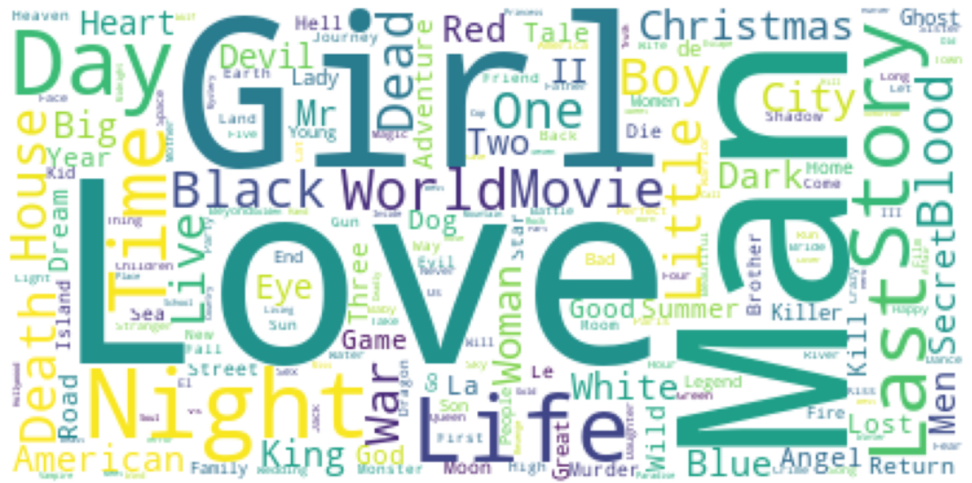

The word **Love** is the most commonly used word in movie titles. **Girl** and **Man** are also among the most commonly occurring words. I think this encapsulates the idea of the ubiquitous presence of romance in movies pretty well.

## 3.5 Original Languages

There​ ​are​ ​over​ ​111 languages​ ​represented​ ​in​ ​our​ ​dataset.​ ​As​ ​we​ ​had​ ​expected,​ ​English​ ​language films​ ​form​ ​the​ overwhelmingly​ ​majority.​ ​French​ ​and​ ​Italian​ ​movies​ ​come​ ​at​ ​a​ ​very​ ​distant​ ​second and​ ​third​ ​respectively.

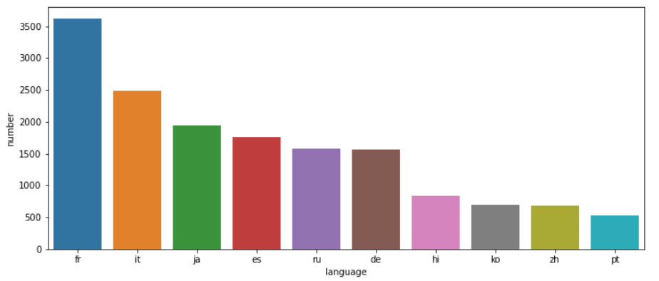

As​ ​mentioned​ ​earlier,​ ​French​ ​and​ ​Italian​ ​are​ ​the​ ​most​ ​commonly​ ​occurring​ ​languages​ ​after English.​ ​Japanese​ ​and​ ​Hindi​ ​form​ ​the​ ​majority​ ​as​ ​far​ ​as​ ​Asian​ ​Languages​ ​are​ ​concerned.

## 3.6 Popularity, Vote Average and Vote count

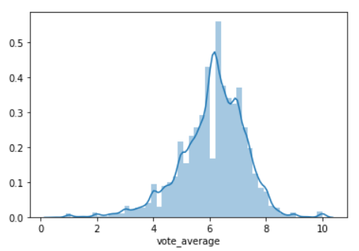

1. **Joker**. is the most popular movie by the TMDB Popularity Score. Frozen II and Avengers: Infinity War movies come in second and third respectively.
2. Inception​ ​and​ ​The​ ​Dark​ ​Knight,​ ​two​ ​critically​ ​acclaimed​ ​and​ ​commercially​ ​successful Christopher​ ​Nolan​ ​movies​ ​figure​ ​at​ ​the​ ​top​ ​of​ ​The​ ​Most​ ​Voted​ ​On​ ​Movies​ ​Chart.
3. The​ ​Shawshank​ ​Redemption​ ​and​ ​The​ ​Godfather​ ​are​ ​the​ ​two​ ​most​ ​critically​ ​acclaimed movies​ ​in​ ​the​ ​TMDB​ ​Database.​ ​Interestingly,​ ​they​ ​are​ ​the​ ​top​ ​2​ ​movies​ ​in​ ​IMDB's​ ​Top​ ​250 Movies​ ​list​ ​too.​ ​They​ ​have​ ​a​ ​rating​ ​of​ ​over​ ​9​ ​on​ ​IMDB​ ​as​ ​compared​ ​to​ ​their​ ​8.5​ ​TMDB Scores.

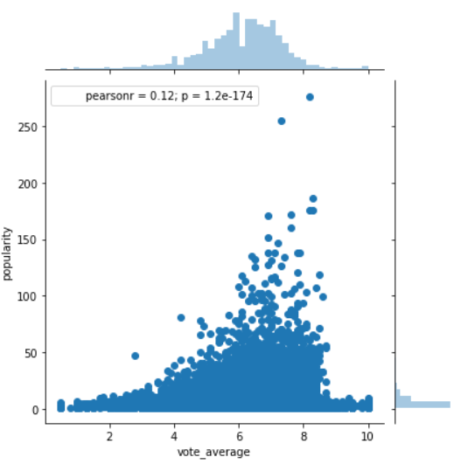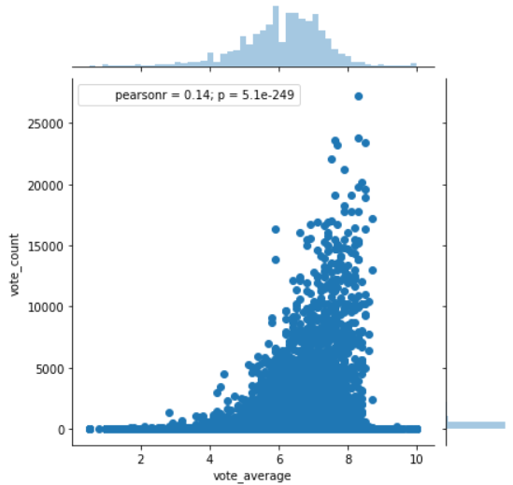

1. Surprisingly,​ ​the​ ​Pearson​ ​Coefficient​ ​of​ ​the​ ​two​ ​aforementioned​ ​quantities​ ​is​ ​a​ ​measly 0.12 which​ ​suggests​ ​that​ ​there​ ​is​ ​no​ ​tangible​ ​correlation.​ ​In​ ​other​ ​words,​ ​popularity​ ​and vote​ ​average​ ​and​ ​independent​ quantities. Which means a large number of votes on a particular movie does not necessarily imply that movie is popular
2. There is a very small correlation between Vote Count and Vote Average. A large number of votes on a particular movie does not necessarily imply that the movie is good.

## 3.7 Movie Release Dates

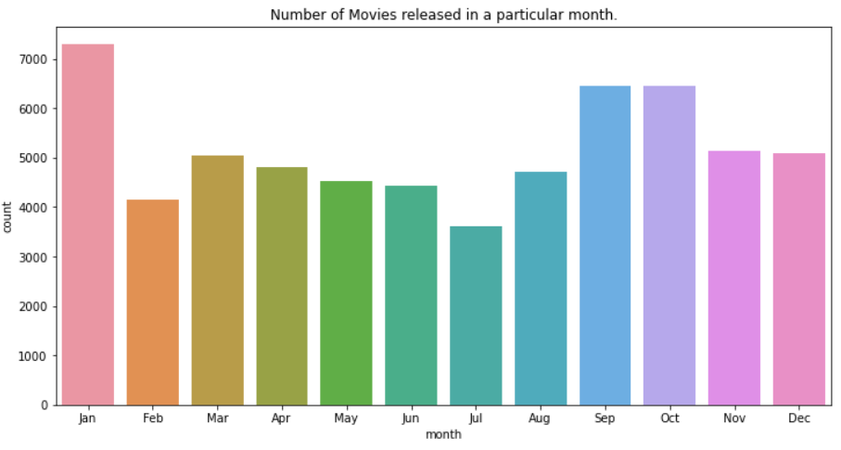

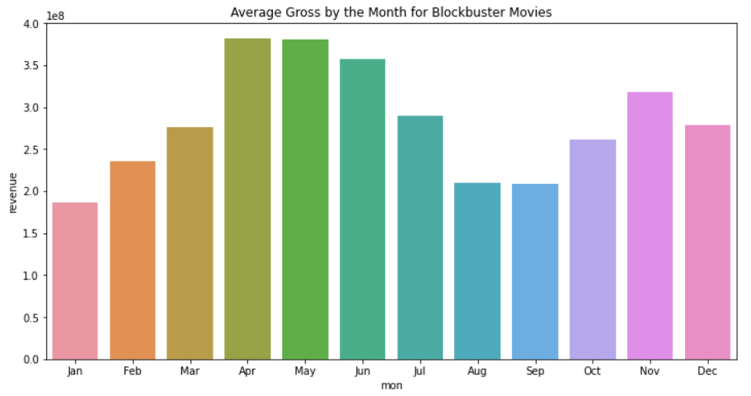

It​ ​appears​ ​that​ ​January​ ​is​ ​the​ ​most​ ​popular​ ​month​ ​when​ ​it​ ​comes​ ​to​ ​movie​ ​releases.​ ​In​ ​Hollywood circles,​ ​this​ ​is​ ​also​ ​known​ ​as​ ​the​ ​​ ​dump​ ​month​ ​when​ ​subpar​ ​movies​ ​are​ ​released​ ​by​ ​the dozen.

We​ ​see​ ​that​ ​the​ ​months​ ​of​ ​April,​ ​May​ ​and​ ​June​ ​have​ ​the​ ​highest​ ​average​ ​gross​ ​among​ ​high grossing​ ​movies.​ ​This​ ​can​ ​be​ ​attributed​ ​to​ ​the​ ​fact​ ​that​ ​blockbuster​ ​movies​ ​are​ ​usually​ ​released in​ ​the​ ​summer​ ​when​ ​the​ ​kids​ ​are​ ​out​ ​of​ ​school​ ​and​ ​the​ ​parents​ ​are​ ​on​ ​vacation​ ​and​ ​therefore,​ ​the audience​ ​is​ ​more​ ​likely​ ​to​ ​spend​ ​their​ ​disposable​ ​income​ ​on​ ​entertainment.

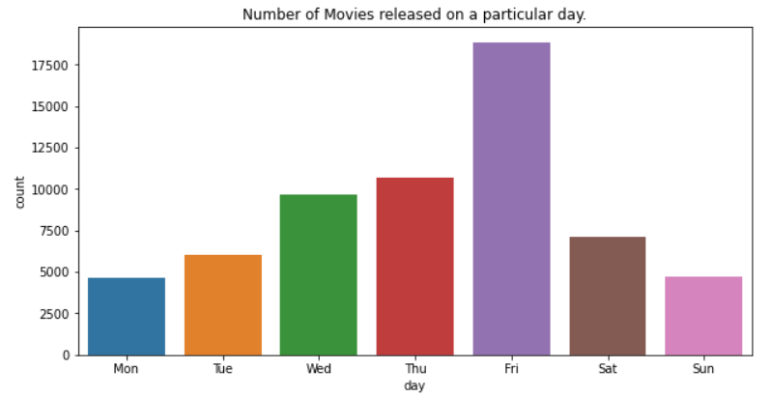

Friday​ ​is​ ​clearly​ ​the​ ​most​ ​popular​ ​day​ ​for​ ​movie​ ​releases.​ ​This​ ​is​ ​understandable​ ​considering​ ​the fact​ ​that​ ​it​ ​usually​ ​denotes​ ​the​ ​beginning​ ​of​ ​the​ ​weekend.​ ​Sunday​ ​and​ ​Monday​ ​are​ ​the​ ​least popular​ ​days​ ​and​ ​this​ ​can​ ​be​ ​attributed​ ​to​ ​the​ ​same​ ​aforementioned​ ​reason.

## 3.8 Spoken Languages

The​ ​movie​ ​with​ ​the​ ​most​ ​number​ ​of​ ​languages, Train Station is a movie about the character he/she misses a train. From there, the directors take Brown on a fantastical journey and throughout it illustrate the infinite possibilities that exist when a single event interrupts a person's timeline. Each decision s/he makes leads to a different scenario, each one told by a different director. ​This​ ​explains​ ​the​ ​sheer​ ​diversity​ ​of​ ​the​ ​movie​ ​in terms​ ​of​ ​language.

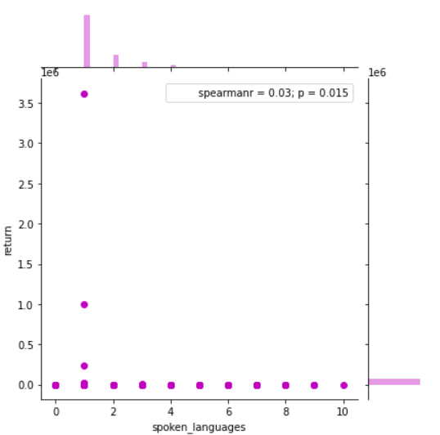

There​ ​is​ ​no​ ​correlation​ ​between​ ​the​ ​number​ ​of​ ​languages​ ​and​ ​returns​ ​of​ ​a​ ​movie.

## 3.9 Runtime

The​ ​average​ ​length​ ​of​ ​a​ ​movie​ ​is​ ​about​ ​1​ ​hour​ ​and​ ​30​ ​minutes.​ ​The​ ​longest​ ​movie​ ​on​ ​record​ ​in this​ ​dataset​ ​is​ ​a​ ​staggering​ ​902​ ​minutes​ ​(or​ ​15 hours)​ ​long.

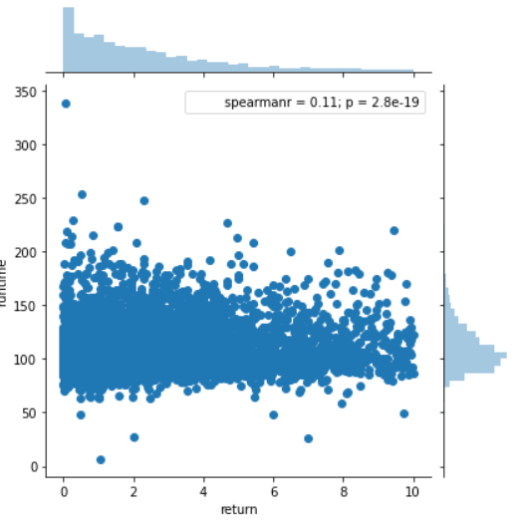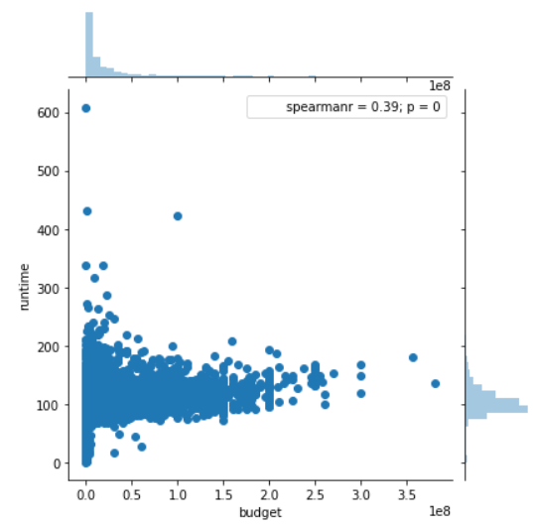

* There​ ​seems​ ​to​ ​be​ ​no​ ​relationship​ ​between​ ​runtime​ ​and​ ​return.​ ​The​ ​success of​ ​a​ ​movie​ ​is independent​ ​of​ ​its​ ​duration.
* The two quantities, runtime and budget have a much weaker correlation than I had expected. In retrospect, the genre of the movie tends to have a much greater impact on budget. A 3 hour art film will cost significantly lesser than a 90 minute Sci-Fi movie.

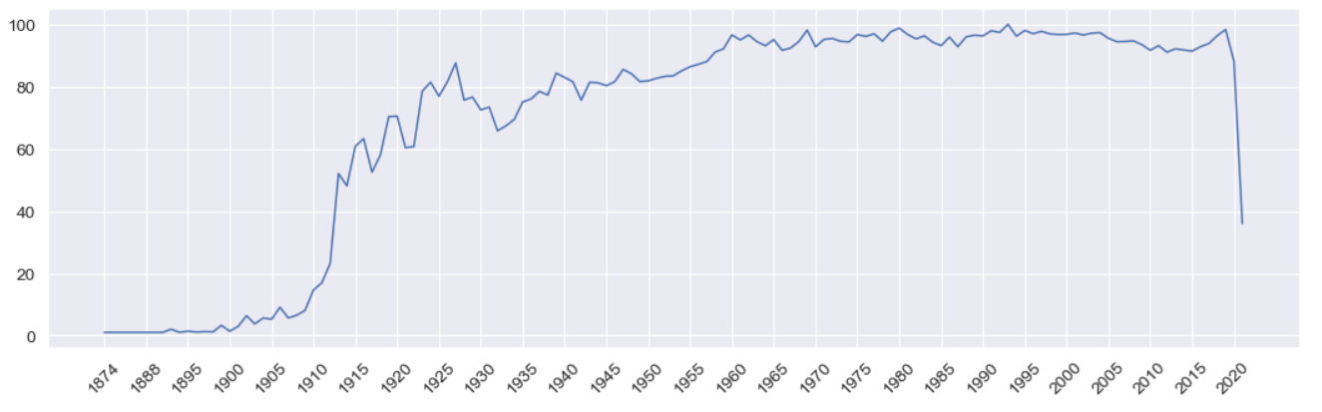

We​ ​notice​ ​that​ ​films​ ​started​ ​hitting​ ​the​ ​60​ ​minute​ ​mark​ ​as​ ​early​ ​as​ ​1914.​ ​Starting​ ​1924,​ ​films started​ ​having​ ​the​ ​traditional​ ​90​ ​minute​ ​duration​ ​and​ ​has​ ​remained​ ​more​ ​or​ ​less​ ​constant​ ​ever since.

## 3.10 Budget

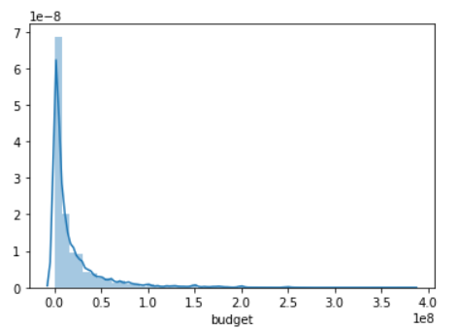

The​ ​distribution​ ​of​ ​movie​ ​budgets​ ​shows​ ​an​ ​exponential​ ​decay.​ ​More​ ​than​ ​75%​ ​of​ ​the​ ​movies have​ ​a​ ​budget​ ​smaller​ ​than​ ​25​ ​million​ ​dollars.

Two Pirates of the Carribean films occupy the top spot in this list and 5th spot with a staggering budget of over 300 million dollars. In between superhero movies collections Avengers: Endgame, Avengers: infinity war, Justice League were present.

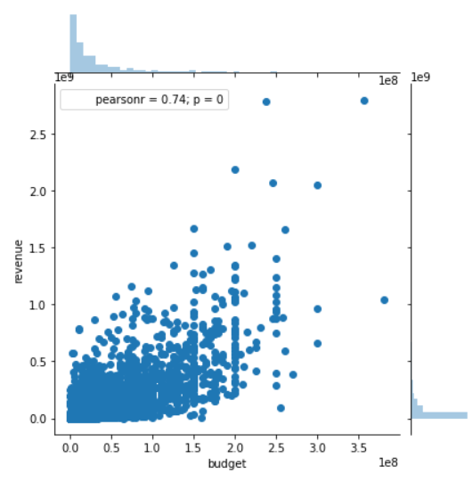

The Pearson r value of 0.73 between the two quantities indicates a very strong correlation.

## 3.11 Revenue

The mean gross of a movie is **63.1 million dollars** whereas the median gross is much lower at **12.9 million dollars**, suggesting the skewed nature of revenue. The lowest revenue generated by a movie is just 1 dollar whereas the highest grossing movie of all time has raked in an astonishing **2.78 billion dollars**.

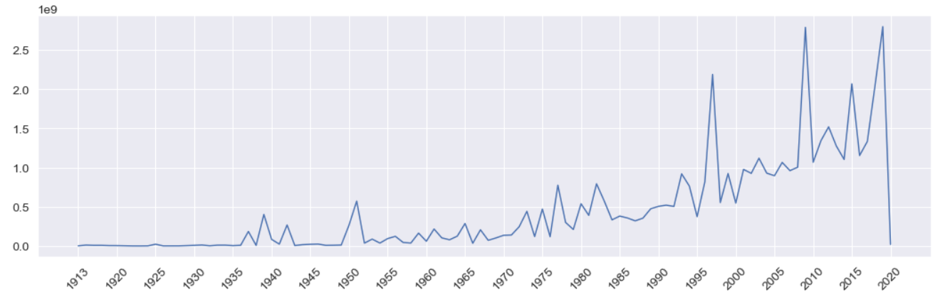

As can be seen from the figure, the maximum gross has steadily risen over the years. The world of movies broke the 1 billion dollar mark in 1997 with the release of Titanic. It took another 12 years to break the 2 billion dollar mark with Avatar. Both these movies were directed by James Cameron.

## 3.12 Genres

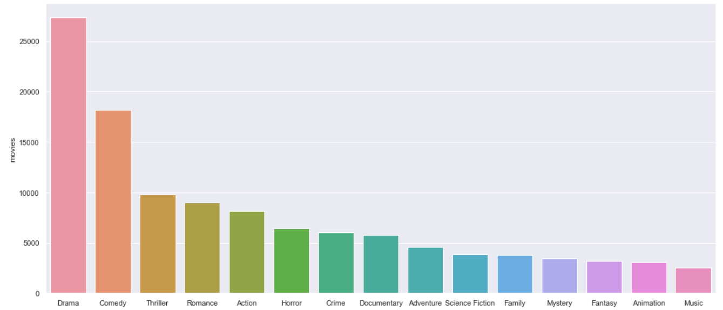

**Drama** is the most commonly occurring genre with almost half the movies identifying itself as a drama film. Comedy comes in at a distant second with 25% of the movies having adequate doses of humor. Other major genres represented in the top 10 are Action, Horror, Crime, Mystery, Science Fiction, Animation and Fantasy.

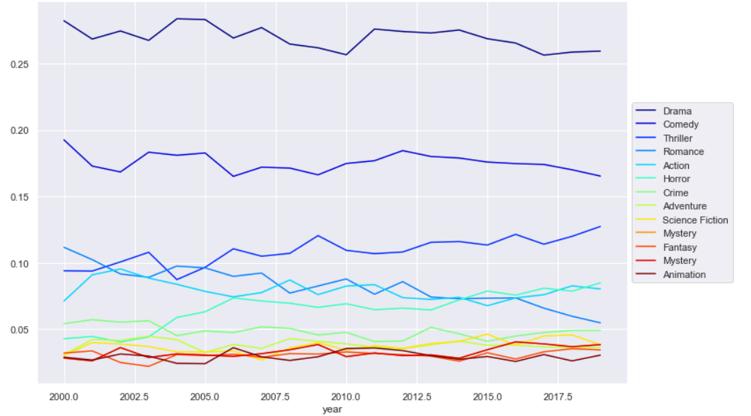

The proportion of movies of each genre has remained fairly constant since the beginning of this century except for Drama. The proportion of drama films has fallen by over 5%. Thriller movies have enjoyed a slight increase in their share.

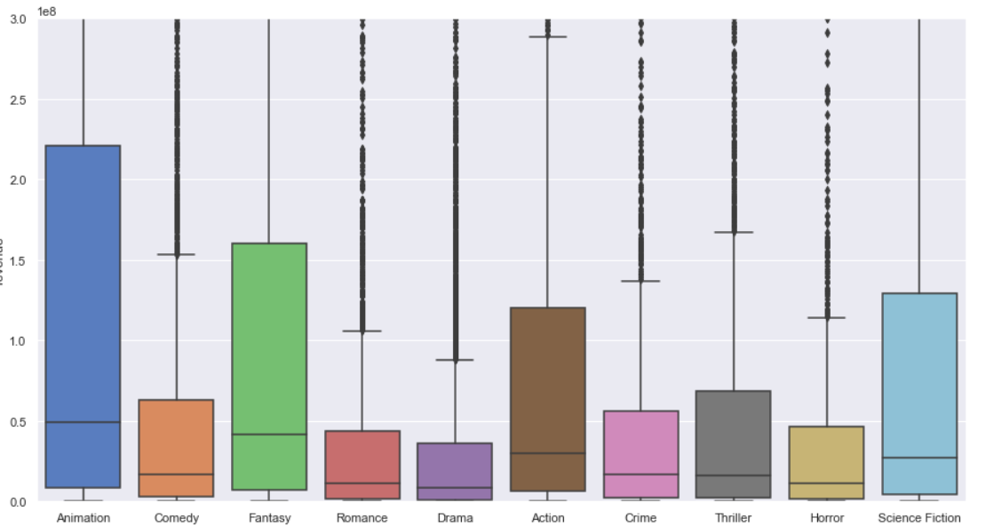

**Animation** movies has the largest 25-75 range as well as the median revenue among all the genres plotted. **Fantasy and Science Fiction** have the second and third highest median revenue respectively.

## 3.13 Cast & Crew

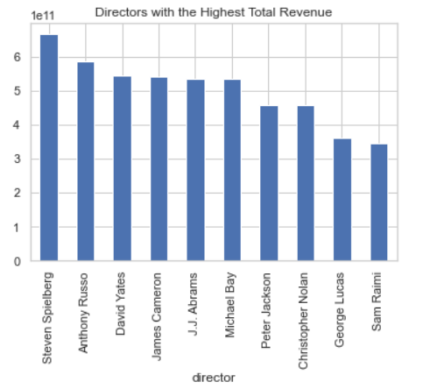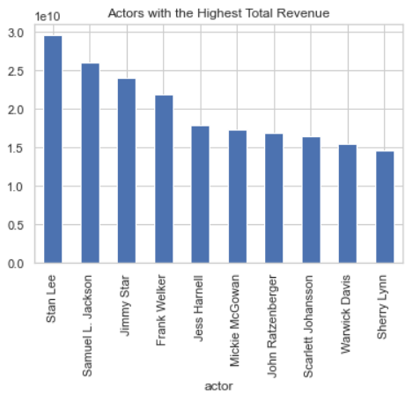

# 4. Regression: Predicting Movie Revenue

Predicting​ ​Movie​ ​Revenues​ ​is​ ​an​ ​extremely​ ​popular​ ​problem​ ​in​ ​Machine​ ​Learning We​ ​will​ ​be​ ​using TMDB's​ ​Popularity​ ​Score​ ​and​ ​Vote​ ​Average​ ​as​ ​our​ ​features​ ​in​ ​our​ ​model​ ​to​ ​assign​ ​a​ ​numerical value​ ​to​ ​popularity.​ ​However,​ ​it​ ​must​ ​be​ ​kept​ ​in​ ​mind​ ​that​ ​these​ ​metrics​ ​will​ ​not​ ​be​ ​available​ ​when predicting​ ​movie​ ​revenues​ ​in​ ​the​ ​real​ ​world,​ ​when​ ​the​ ​movie​ ​has​ ​not​ ​been​ ​released​ ​yet.

## 4.1 Feature Engineering

We will perform the following feature engineering tasks:

1. **belongs_to_collection** will be turned into a Boolean variable. 1 indicates a movie is a part of collection whereas 0 indicates it is not.
2. **genres** will be converted into number of genres.
3. **homepage** will be converted into a Boolean variable that will indicate if a movie has a homepage or not.
4. **original_language** will be replaced by a feature called **is_foreign** to denote if a particular film is in English or a Foreign Language.
5. **Production_companies** will be replaced with just the number of production companies collaborating to make the movie.
6. **Production_countries** will be replaced with the number of countries the film was shot in.
7. **day** will be converted into a binary feature to indicate if the film was released on a Friday.
8. **month** will be converted into a variable that indicates if the month was a holiday season.

## 4.2 Model

The​ ​model​ ​that​ ​I​ ​choose​ ​for​ ​regression​ ​is​ ​the​ ​Gradient​ ​Boosting​ ​Regression.​ ​The​ ​Coefficient​ ​of Determination​ ​Score​ ​obtained​ ​by​ ​the​ ​regressor​ ​was​ ​0.79.

­­­­­­

## 4.3 Feature Importance

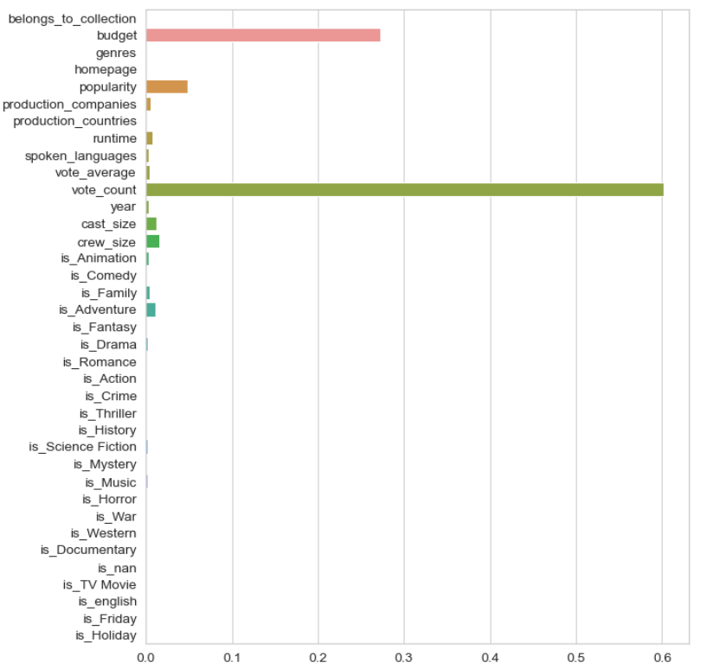

We notice that **vote_count**, is the most important feature to our Gradient Boosting Model. This goes on to show the importance of popularity metrics in determining the revenue of a movie. **Budget** was the second most important feature followed by **Popularity**.

# 5. Classification: Predicting Movie Success

The​ ​Classification​ ​model​ ​uses​ ​the​ ​same​ ​Feature​ ​Engineering​ ​steps​ ​as​ ​those​ ​followed​ ​by​ ​the Regression​ ​Model​ ​built​ ​in​ ​the​ ​previous​ ​section.

## Model

The​ ​model​ ​that​ ​I​ ​choose​ ​for​ ​classification​ ​is​ ​the​ ​Gradient​ ​Boosting​ ​Classifier.​ ​The​ ​model showcased​ ​an​ ​accuracy​ ​of​ ​77%​ ​with​ ​unseen​ ​test​ ​cases

## Feature Importance

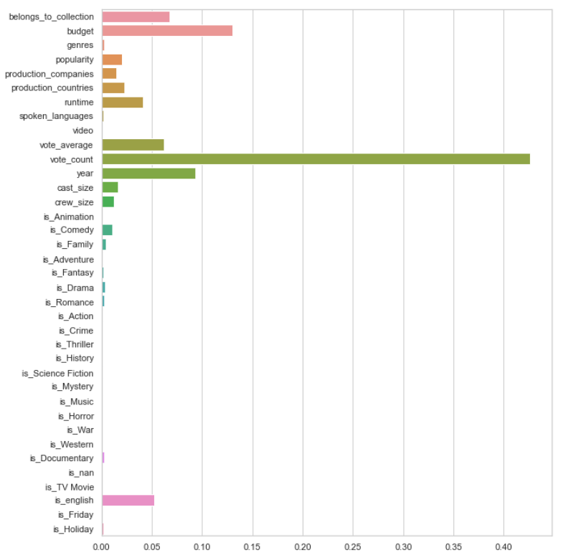

We see that **Vote Count** is once again the most significant feature identified by our Classifier. Other important features include **Budget**, **belongs_to_collection** and **Year**. With this, we will conclude our discussion on the classification model and move on to the main part of the project.

# 6. Recommendation Systems

A **Recommender System** refers to a **system** that is capable of predicting the future preference of a set of items for a user, and recommend the top items.

## 6.1 Simple Recommender

The​ ​Simple​ ​Recommender​ ​offers​ ​generalized​ ​recommendations​ ​to​ ​every​ ​user​ ​based​ ​on​ ​movie popularity​ ​and​ (sometimes)​ ​genre.​ ​The​ ​basic​ ​idea​ ​behind​ ​this​ ​recommender​ ​is​ ​that​ ​movies​ ​that are​ ​more​ ​popular​ ​and​ ​more​ ​critically​ ​acclaimed​ ​will​ ​have​ ​a​ ​higher​ ​probability​ ​of​ ​being​ ​liked​ ​by​ ​the average​ ​audience.​ ​This​ ​model​ ​does​ ​not​ ​give​ ​personalized​ ​recommendations​ ​based​ ​on​ ​the​ ​user.  
I​ ​used​ ​the​ ​TMDB​ ​Ratings​ ​to​ ​come​ ​up​ ​with​ ​our​ ​Top​ ​Movies​ ​Chart.​ ​I​ ​used​ ​IMDB's​ ​weighted​ ​rating formula​ ​to​ ​construct​ ​my​ ​chart.

The​ ​next​ ​step​ ​was​ ​to​ ​determine​ ​an​ ​appropriate​ ​value​ ​for​ ​m,​ ​the​ ​minimum​ ​votes​ ​required​ ​to​ ​be listed​ ​in​ ​the​ ​chart.​ ​I​ ​used​ ​95th​ ​percentile​ ​as​ ​the​ ​cutoff.​ ​In​ ​other​ ​words,​ ​for​ ​a​ ​movie​ ​to​ ​feature​ ​in​ ​the charts,​ ​it​ ​must​ ​have​ ​more​ ​votes​ ​than​ ​at​ ​least​ ​95%​ ​of​ ​the​ ​movies​ ​in​ ​the​ ​list.

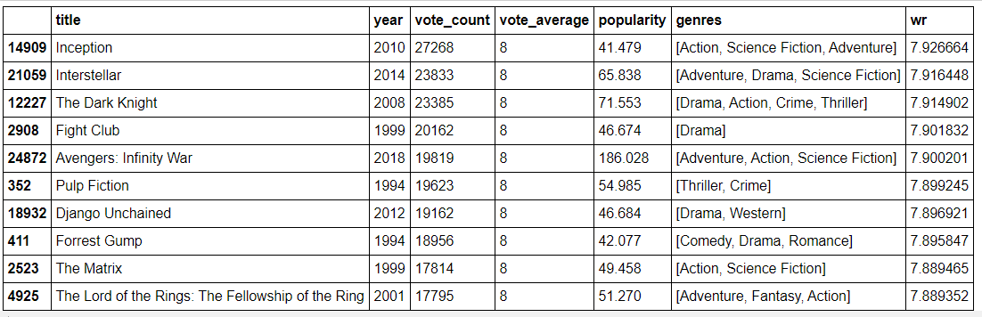

These are the top 10 movie recommendation from the Simple Recommender which can be used for a new user.

## 6.2 Content Based Recommender

My​ ​approach​ ​to​ ​building​ ​the​ ​recommender​ ​was​ ​extremely​ ​hacky.​ ​What​ ​I​ ​did​ ​was​ ​create​ ​a metadata​ ​dump​ ​for​ ​every​ ​movie​ ​which​ ​consisted​ ​of​ ​genres,​ ​director,​ ​main​ ​actors​ ​and​ ​keywords.​ ​I then​ ​used​ ​a​ ​Countvectorizer​ ​to​ ​create​ ​a​ ​count​ ​matrix.​ ​I​ ​then​ ​calculated​ ​the​ ​cosine​ ​similarities​ ​and returned​ ​movies​ ​that​ ​are​ ​most​ ​similar.

I​ ​also​ ​added​ ​a​ ​mechanism​ ​to​ ​remove​ ​bad​ ​movies​ ​and​ ​return​ ​movies​ ​which​ ​are​ ​popular​ ​and​ ​have had​ ​a​ ​good​ ​critical​ ​response

I​ ​took​ ​the​ ​top​ ​25​ ​movies​ ​based​ ​on​ ​similarity​ ​scores​ ​and​ ​calculate​ ​the​ ​vote​ ​of​ ​the​ ​60th​ ​percentile movie.​ ​Then,​ ​using​ ​this​ ​as​ ​the​ ​value​ ​of​ ​​ ​m​ ​,​ ​I​ ​calculated​ ​the​ ​weighted​ ​rating​ ​of​ ​each​ ​movie​ ​using IMDB's​ ​formula​ ​like​ ​I​ ​did​ ​with​ ​the​ ​Simple​ Recommender.

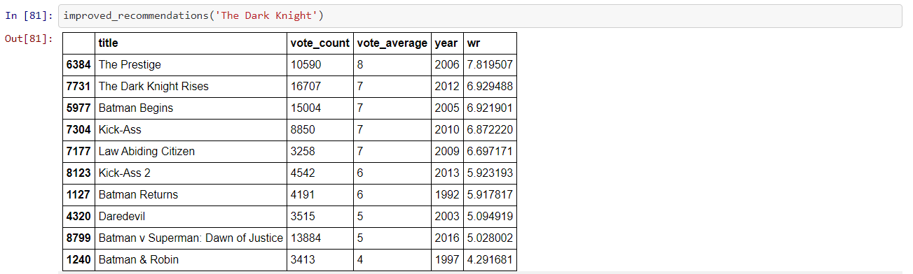

## 6.3 Collaborative Filtering

The​ ​content​ ​based​ ​engine​ ​suffers​ ​from​ ​some​ ​severe​ ​limitations.​ ​It​ ​is​ ​only​ ​capable​ ​of​ ​suggesting movies​ ​that​ ​are​ ​close​ ​to​ ​a​ ​certain​ ​movie.​ ​That​ ​is,​ ​it​ ​is​ ​not​ ​capable​ ​of​ ​capturing​ ​tastes​ ​and providing​ ​recommendations​ ​across​ ​genres.

Also,​ ​the​ ​engine​ ​that​ ​I​ ​built​ ​is​ ​not​ ​really​ ​personal​ ​in​ ​that​ ​it​ ​doesn't​ ​capture​ ​the​ ​personal​ ​tastes​ ​and biases​ ​of​ ​a​ ​user.​ ​Anyone​ ​querying​ ​our​ ​engine​ ​for​ ​recommendations​ ​based​ ​on​ ​a​ ​movie​ ​will receive​ ​the​ ​same​ ​recommendations​ ​for​ ​that​ ​movie,​ ​regardless​ ​of​ ​who​ ​s/he​ ​is.

Therefore,​ ​I​ ​used​ ​a​ ​technique​ ​called​ ​Collaborative​ ​Filtering​ ​to​ ​make​ ​recommendations​ ​to​ ​Movie Watchers.​ ​Collaborative​ ​Filtering​ ​is​ ​based​ ​on​ ​the​ ​idea​ ​that​ ​users​ ​similar​ ​to​ ​a​ ​me​ ​can​ ​be​ ​used​ ​to predict​ ​how​ ​much​ ​I​ ​will​ ​like​ ​a​ ​particular​ ​product​ ​or​ ​service​ ​those​ ​users​ ​have​ ​used/experienced but​ ​I​ ​have​ ​not.

I​ ​did​ ​not​ ​implement​ ​Collaborative​ ​Filtering​ ​from​ ​scratch.​ ​Instead,​ ​I​ ​used​ ​the​ ​Surprise​ ​library​ ​that provides​ ​extremely​ ​powerful​ ​algorithms​ ​like​ ​Singular​ ​Value​ ​Decomposition​ ​(SVD)​ ​to​ ​minimize RMSE​ ​(Root​ ​Mean​ ​Square​ ​Error)​ ​and​ ​give​ ​great​ ​recommendations.

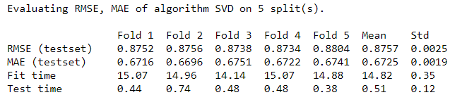

## 6.4 Hybrid Recommender

The​ ​Hybrid​ ​Recommender​ ​brought​ ​together​ ​techniques​ ​from​ ​both​ ​Content​ ​Based​ ​and Collaborative​ ​Filtering​ ​Based​ ​engines​ ​to​ ​provide​ ​personalized​ ​Similar​ ​Movie​ ​Recommendations to​ ​Users​ ​based​ ​on​ ​their​ ​taste.

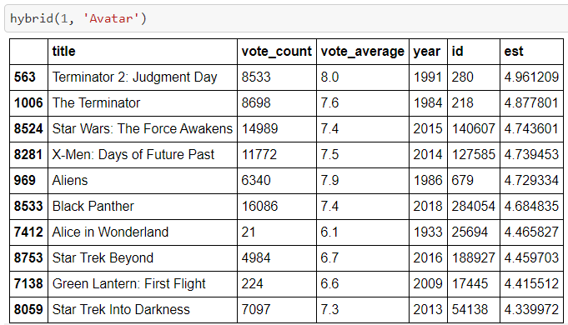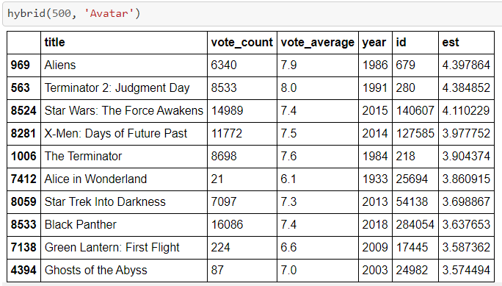

We see that for our hybrid recommender, we get different recommendations for different users although the movie is the same. Hence, our recommendations are more personalized and tailored towards particular users.

# 7. Conclusion

This​ ​report​ ​highlighted​ ​the​ ​processes​ ​of​ ​data​ ​wrangling,​ ​inferential​ ​statistics,​ ​data​ ​visualization, feature​ ​engineering​ ​and​ ​predictive​ ​modelling​ ​performed​ ​on​ ​the​ ​Movies​ ​Dataset.​ ​All​ ​the​ ​results and​ ​insights​ ​gained​ ​as​ ​part​ ​of​ ​these​ ​processes​ ​were​ ​also​ ​highlighted.​ ​With​ ​these​ ​insights,​ ​a Gradient​ ​Boosting​ ​Regressor​ ​and​ ​Classifier​ ​were​ ​built​ ​to​ ​predict​ ​Movie​ ​Revenue​ ​and​ ​Success respectively​ ​with​ ​a​ ​Score​ ​of​ ​0.78​ ​and​ ​0.8​ ​respectively.

In​ ​addition,​ ​four​ ​recommendation​ ​engines​ ​were​ ​built​ ​based​ ​on​ ​different​ ​ideas​ ​and​ ​algorithms:

1. **Simple**​ ​**Recommender**:​ ​This​ ​system​ ​used​ ​overall​ ​TMDB​ ​Vote​ ​Count​ ​and​ ​Vote​ ​Averages​ ​to build​ ​Top​ ​Movies​ ​Charts,​ ​in​ ​general​ ​and​ ​for​ ​a​ ​specific​ ​genre.​ ​The​ ​IMDB​ ​Weighted​ ​Rating System​ ​was​ ​used​ ​to​ ​calculate​ ​ratings​ ​on​ ​which​ ​the​ ​sorting​ ​was​ ​finally​ ​performed.  
2. **Content**​ ​**Based**​ ​**Recommender**:​ ​We​ ​built​ ​two​ ​content​ ​based​ ​engines;​ ​one​ ​that​ ​took​ ​movie overview​ ​and​ ​taglines​ ​as​ ​input​ ​and​ ​the​ ​other​ ​which​ ​took​ ​metadata​ ​such​ ​as​ ​cast,​ ​crew, genre​ ​and​ ​keywords​ ​to​ ​come​ ​up​ ​with​ ​predictions.​ ​We​ ​also​ ​devised​ ​a​ ​simple​ ​filter​ ​to​ ​give greater​ ​preference​ ​to​ ​movies​ ​with​ ​more​ ​votes​ ​and​ ​higher​ ​ratings.  
3. **Collaborative**​ ​**Filtering**:​ ​We​ ​used​ ​the​ ​powerful​ ​Surprise​ ​Library​ ​to​ ​build​ ​a​ ​collaborative filter​ ​based​ ​on​ ​singular​ ​value​ ​decomposition.​ ​The​ ​RMSE​ ​obtained​ ​was​ ​less​ ​than​ ​1​ ​and​ ​the engine​ ​gave​ ​estimated​ ​ratings​ ​for​ ​a​ ​given​ ​user​ ​and​ ​movie.  
4. **Hybrid**​ ​**Engine**:​ ​We​ ​brought​ ​together​ ​ideas​ ​from​ ​content​ ​and​ ​collaborative​ ​filtering​ ​to build​ ​an​ ​engine​ ​that​ ​gave​ ​movie​ ​suggestions​ ​to​ ​a​ ​particular​ ​user​ ​based​ ​on​ ​the​ ​estimated ratings​ ​that​ ​it​ ​had​ ​internally​ ​calculated​ ​for​ ​that​ ​user.